Technical Architecture Document – v5.0

MKG Process Tracking System

Author: Data Architecture Team Date Submitted: November 8, 2026

Review
Participant Name | Area Represented
Ed Mclaughlin | MKG AD
Andrew London | MKG Operations
Darek Wiszniewski | DMC, AS, RPM
Satish Gadiraju | DCS, DTM
Craig Chapa | FDW
Jay Yusko | BRMS
Miles Galfer | FDW
Jeff Wallk | OMS

Approval
Participant Name |  | Area Represented | Signature | Date
Andrew London | Operations
Ed Mclaughlin | AD
Craig Chapa | Acxiom

Revision History
Date | Revision # | Process/Group | Comments
1/22/05 | 1.0 | AD
1/23/05 | 2.0 | AD
1/24/2005 | 3.0 | AD
1/25 | 4.0 | AD | After review with TA’s
1/26 | 5.0 | AD

Team List
Participant Name | Area Represented | Phone # | Role

Table of Contents

1.1. Audience for this document 3
1.2. Error/Event Handler Module Audience 3
1.2.1. Information Provider 3
1.2.2. Information Consumer 3
1.3. Error/Event Handler Module Purpose & Scope 3
1.4. Error/Event Handler Module Architecture 4
1.4.1. Architecture Diagram 4
1.4.2. Architecture Description 5
1.1.1.1. BBGen3 Application Components 5
1.1.1.2. Long term Module Components 5
1.1.1.2.1. Process flow of logging events/errors 5
1.4.3. Conventions for Logging Events and Errors 7
1.1.1.3. Common IDL Specification 8
1.1.1.4. Example of Process Log 8
1.1.1.5. Standard Error Log File Layout 8
1.1.1.6. Handling Component Failures 9
1.4.4. Error/Event Handler Data Model: 10

Audience for this document
All TA’s, BA’s and Business End users who need to provide data to the module and consume information from it.

Process Tracking Module Audience

Information Provider
MKG Application Modules:

- DTM: Data Transfer Manager
- DCS: Data Cleansing and Scrubbing
- FDW: Factory Data Warehouse
- DMC: Data Mart Creation
- DM: Data Mart
- AS: Analytic Server
- BRMS: Business Rules Management System
- OMS: Order Management System

Information Consumer
MarketKnowledge (MKG) Operations

Process Tracking Module Purpose & Scope
The purpose of the MKG Process Tracking System will be to provide a central dashboard for Operations to monitor and track the progress and statuses of all processes running the MKG factory.

It will be the central repository of all significant events process steps in a MKG application process flow and any error(s) raised by MKG applications in that flow. It will include errors not necessarily caused by the module itself but encountered by it.

The implication is that - the errors raised can include not only the errors created by the application modules, but also errors defined by the 3rd party vendor components such as – HW (server + network), OS, Database Software, Grid Management Software, etc.

The errors can be dependent on the content that is being processed or independent of the content being processed. Errors dependent on the content will provide include a pointer to a standard directory that will contain the error log for further investigation.

Process Tracking Module Architecture

Architecture Diagram

NOTE: BBGen3 implementation will include ONLY the components in grey.

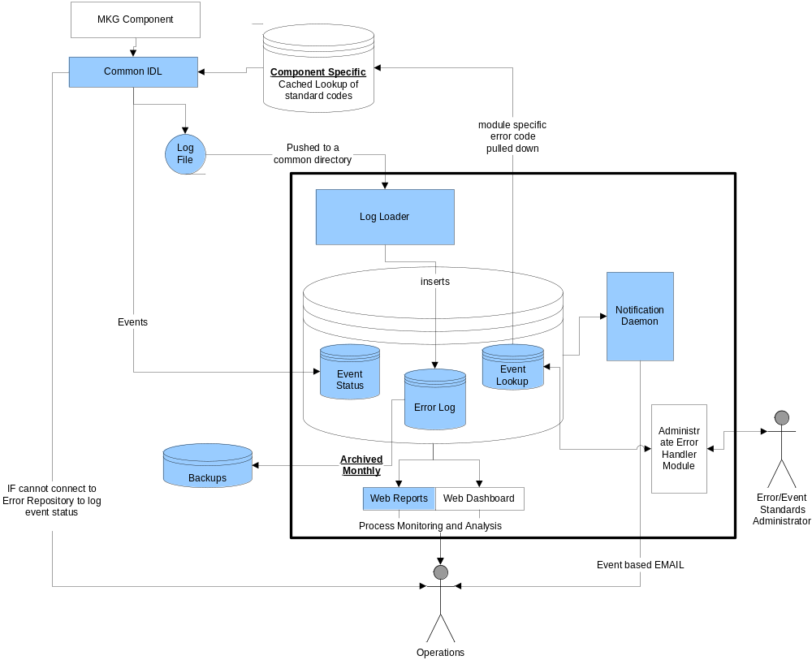

Architecture Description

BBGen3 Application Components

BBGen3 will contain the following components
- Common IDL to log events/errors – an Oracle stored procedure to pass parameters, which can be called directly or through a script or through a trigger – whichever mechanism is feasible for each component
- Error Log Loader – to consolidate errors logs pushed from the components and load into the repository
- Central Error Repository and archival monthly
- Notification Daemon to send out e-mails – central only
- Web reporting tool

Each of the components would call the IDL - an Oracle stored procedure - to log the events along with status and severity for each significant step per agreement with Operations.

- The first function that this significant step would perform after it starts is – to log and event with status = started along with other information as defined.
- As it executes, if it encounters an error it will call this procedure to log the error with error code + message with status = failed and level of severity.
- A notification daemon from the central repository would send an e-mail per contact list for that error.
- If the error is related to processing of content – such as input file format error or lookup failure, then it would spool the error log locally after logging the event.
- On completion of that step, the last function that it will perform is call this procedure to log the event with status = completed, if it completes the step.
- Then it would push the error log to a central error log directory.

A web reporting tool can be used to analyze the logged events
- by date range,
- by application module ,
- by severity of error,
- by error status,
- by job id (execution instance)
- by data supplier code and/or client order number depending on the process step.

Long term Module Components

Error Handler Module will consist of the following components

- Common IDL to log events/errors – web service
- Error Log Loader – to consolidate errors logs pushed from the components and load into the repository
- Local replication mechanism – to provide a local cache of lookups
- Central Error Repository and archival monthly
- Notification Daemon to send out e-mails – local and central
- Web Dashboard for monitoring/analyses
- Administrator Application to maintain codes, thresholds, contacts, SOP’s, and associations between them.

Process flow of logging events/errors

Each process will log a significant event along the process flow – the outcome of which may be a success or a failure. The significant events will be defined by each component owner.

Before logging the event, the component will check if the central error repository is up. If not, it will directly notify a default contact. If the central repository is up, an entry will be logged directly at the database at the start of each of these events. If the event is successful, another entry will be logged at the end of the event stating that the step completed. If an error is encountered, an entry will be logged stating that an error was encountered and local log file will be produced. The local log file will be pushed to a central location for all error logs by the component. These log files will be loaded periodically by a process which will poll those directories for new files.

Conventions for Logging Events and Errors

MKG Application Modules need to follow standard codes for logging errors.

The standard will consist of:
- Set of Application Module Codes :
  - DTM
  - DCS
  - FDW
  - DMC
  - DM
  - AS
  - RPM
  - BRMS
  - OMS
- Process Step Status
  - Started
  - Completed
  - Failed
- Severity Level Codes (for status = Failed):
  - Warning - can proceed but may have encountered a logic or content issue
  - Error - can proceed but surely have encountered a logic or content issue)
  - Fatal Error – cannot proceed, processing stopped

- Process Step Codes :
  - It is starts with the component acronym from left followed by a “-“ and 8 digit sequence number of the process step. For example:
        - PROC-10000000 for Process Tracking System (internal errors)
        - DTM-10000000 for DTM
        - DCS-10000000 for DCS
        - BRMS-10000000 for BRMS
        - FDW-10000000 for FDW
        - DMC-10000000 for DMC
        - AS-10000000 for AS
        - OMS-10000000 for OMS
        - RPM-10000000 for RPM
  - All significant steps of the processes should be logged as events
  - The significant steps are determined by a the TA for each component, based on the process flow that they have designed.
  - At a minimum – Operations should be able to understand the standard process flow by looking at these significant steps.
  - In the event codes should have a notion of the sequence of process flow.

Common IDL Specification

Stored Proc. Parameter List
- Application Module
- Process Step Code
- Process Step Name
- Step Status
- Severity Level
- Logged Date/Time
- Message
- Process Code ( = DataStage Process ID where applicable)
- Context Code (= Supplier Code – for processes before FDW, OR = Client Order Code after FDW)

Example of Process Log

Application Module | Process Step Code | Process Code | Process Step Name | Step Status | Severity Level | Logged Date | Status Message | Context Code
DMC | 0000000010 | 12345 | Data Mart Schema Creation | Started |  | 1/22/2005 10:42 | Pepsi Data Mart Schema | 654
DMC | 0000000030 | 12345 | Data Mart Schema Creation | Completed |  | 1/22/2005 10:50 | Pepsi Data Mart Schema | 654
DMC | 0000000040 | 78798 | Dimension Loading | Started |  | 1/22/2005 10:52:01 | Item Dimension Loading Started | 654
DMC | 0000000040 | 78798 | Dimension Loading | Failed | Fatal Error | 1/22/2005 10:52:26 | -1: Cannot Load Item Dimension (return code + error message)  (error code + error message for system errors from Oracle for example ) | 654

Standard Error Log File Layout

The error log format will be component specific.

Application Module | Process Step Code | Error Message | Error Date/Time | Error Record Format

Handling Component Failures

Failure | Impact | Solution | Implementation | Comments
Hardware | Cannot Monitor/Analyze errors  Cannot get notification | Redundancy | Cluster
Communication | Cannot collect log  Cannot provide notification  Cannot monitor/analyze errors | Redundancy | Multiple networks
MKG Component | Cannot log errors/events | Owned by component owner | Owned by component owner | A threshold be set for polling – that if a new log file does not show up after a event was logged by a component within say… 1 hour – notification to check that component goes to operations
Error Handler Module | Cannot monitor/analyze/collect logs, administer | Failover | HA - Oracle 9i RAC or 10g grid

Process Tracking Data Model

